Plate Tectonics Review:
Plate Tectonics and Earthquakes:
- The earth is made up of 12 tectonic plates. What are the plates all made up of? (layer of earth)
- What are tectonic plate boundaries?______________________________________________________
- Is Florida on a plate boundary?
- As 2 plates move apart what type of boundary is formed?
- As 2 plates move together to form mountains, what kind of boundary is formed
- What kind of boundary forms a rift valley?
- Draw and label the 3 kinds of plate boundaries

- What was the name given to the landmass when the continents were all connected?
- What was the name of the theory that explained the movement of the continents
- What kind of plate movement can cause rapid change
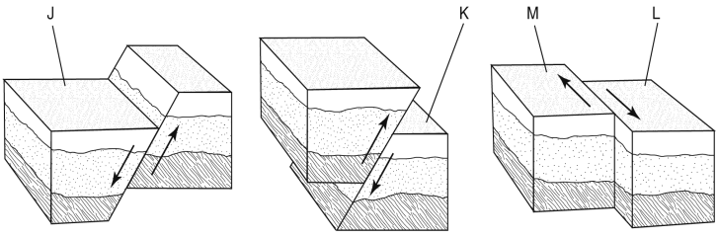
- The picture below shows the 3 kinds of faults. Label them and the footwall, hanging wall and the plates(2)

- What happens when there is a sudden release of energy from the mantle?
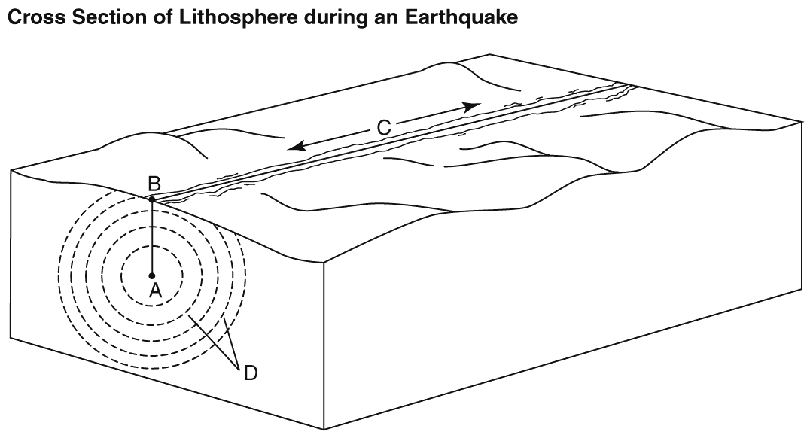
- Label the parts of the earthquake

- Describe what is happening in the illustration below
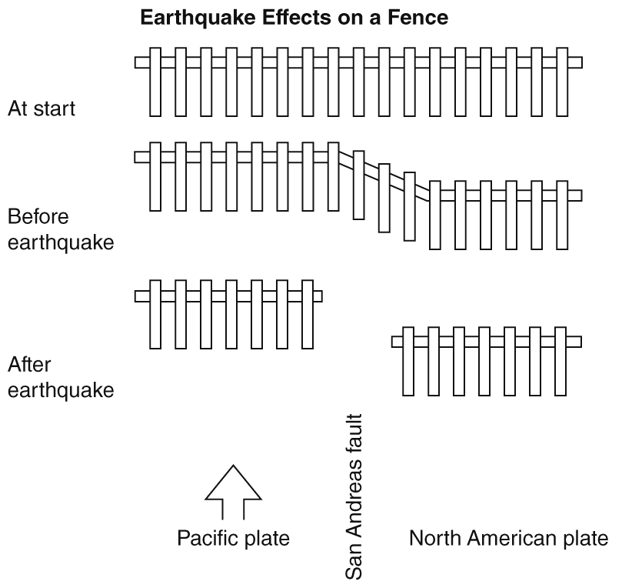
- This process is happening along the San Andreas Fault. What kind of fault is the San Andreas fault?
Mountains and Volcanoes
- What kind of mountain is formed from molten rock that reaches the earth’s surface
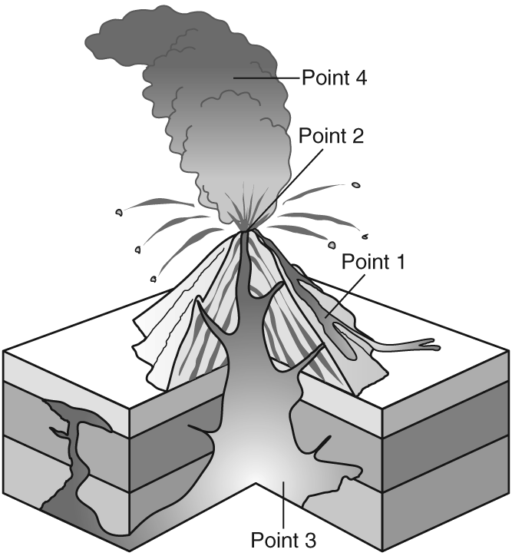
- What kind of mountain has anticlines and synclines?
- What happens to rocks during deformation
- How does energy travel through the crust after an earthquake?
- Label the parts of the volcano

- What are pyroclastic materials? What kind of eruption are they associated with
- Which type of volcano has gently sloping sides and erupts nonexplosively
- Describe the type of eruption and the shape of the sides of a cindercone volcano
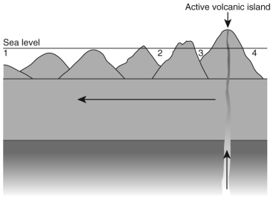
- What volcanic feature is a small depression around a volcano’s vent
- The volcano in the diagram is associated with what kind of location?

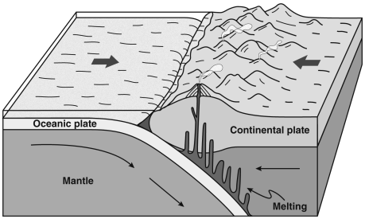
- What is formed in the diagram at right?
- Describe what is happening.

- What is magma
- What is a tectonically active area that includes many volcanoes?

