Land degradation | Air pollution | Water pollution | Point source | Non point source
Rural | Urban | Natural | Agriculture | recreation
Deforestation | Erosion | desertification
Human Impact
- An area with a large human population and higher levels of air pollution ____________
- Human activity that damages the land to the point it can no longer support an ecosystem______________
- Pollutants that enter a body of water at a specific identifiable location _________________________
- Vehicle emissions can lead to __________________
- Pollution that does not have a specific identifiable source ____________________
- Areas with a small human population and more open spaces __________________________
Earth’s Structure
Crust | Mantle | Inner core | Outer core | Liquid
Solid | Rock cycle | Magma | Sediments | Heat and pressure
Metamorphic | Sedimentary | Igneous | Melting and cooling | Convection currents
- Label the layers of the earth below
- Which layer is made up of tectonic plates________________________
- The plates move because of _______________ in the mantle
- Which layer is made of a dense ball of solid metal?____________________
- Which layer is liquid metal ___________________
- Label the rock cycle arrows and pictures:
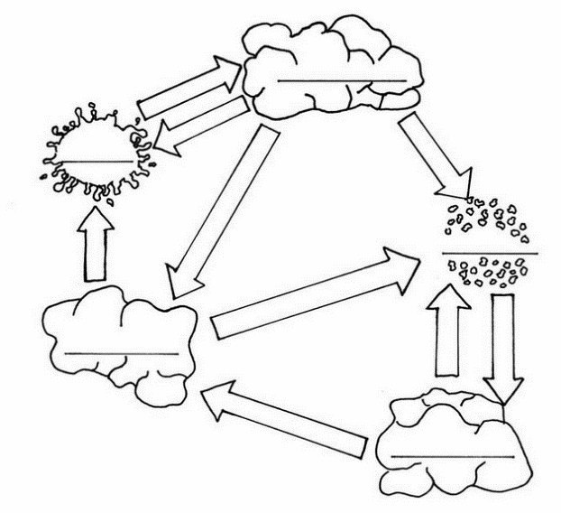
- A series of processes on Earths surface and interior that slowly changes rocks from one kind to another ______________
- Heat and pressure form _________________ rock
- Rock that forms from the cooling of magma below or at the surface ____________________

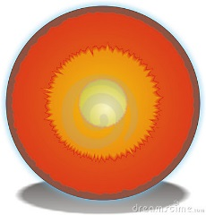

Continental drift | Plate tectonics | Pangaea | Plate boundary | Divergent | Convergent
Transform | Sea floor spreading | Earthquake | Fault | Epicenter | Focus
Seismic waves | Footwall | Hanging wall | Shield | Composite | Cindercone
Magma | Lava | Volcano | Folded | Fault block

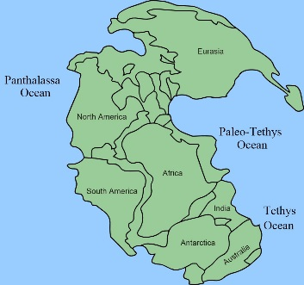
Plate Tectonics
- What is the name given to the supercontinent pictured at right_____________
- Name Alfred Wegener’s theory that stated that the continents were joined in a single landmass ___________________________
- The geological theory that states that pieces of earths lithosphere are in constant slow motion _____________________
- Florida is not on a ______________ so it has few earthquakes like California which is on a _________________ boundary
- A place here 2 plates come together or collide _______________________
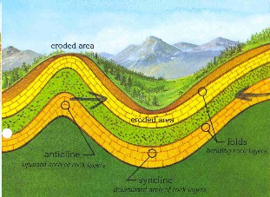
- _______________________ mountains form when blocks or rock are squeezed together
- What kind of mountains are shown _____________
- What is the area where the rock bends upward into an arch called _______________
- A break in a body of rock ________________
- Molten rock under the earth ____________________
- Volcanoes with gently sloping sides and non-explosive eruptions _________________
- Tall volcanoes with alternating violent and quiet eruptions ___________________
- Lava before it reaches the surface is called ____________________
- label the focus, epicenter, fault, and seismic waves in the earthquake below
- Label the vent, lava, magma, ash cloud on the volcano below
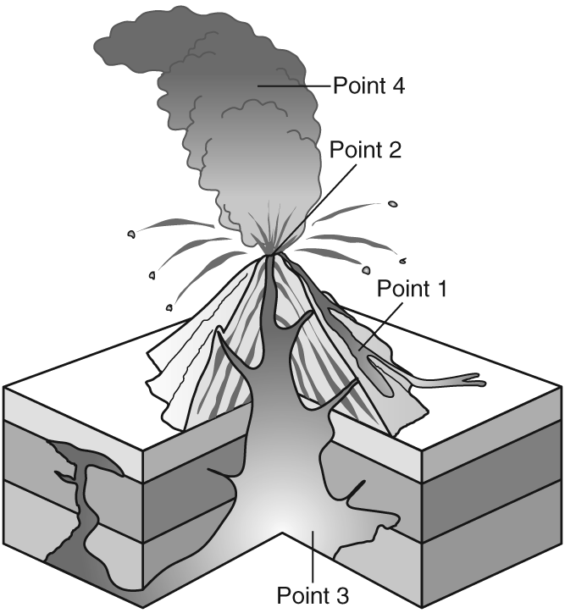
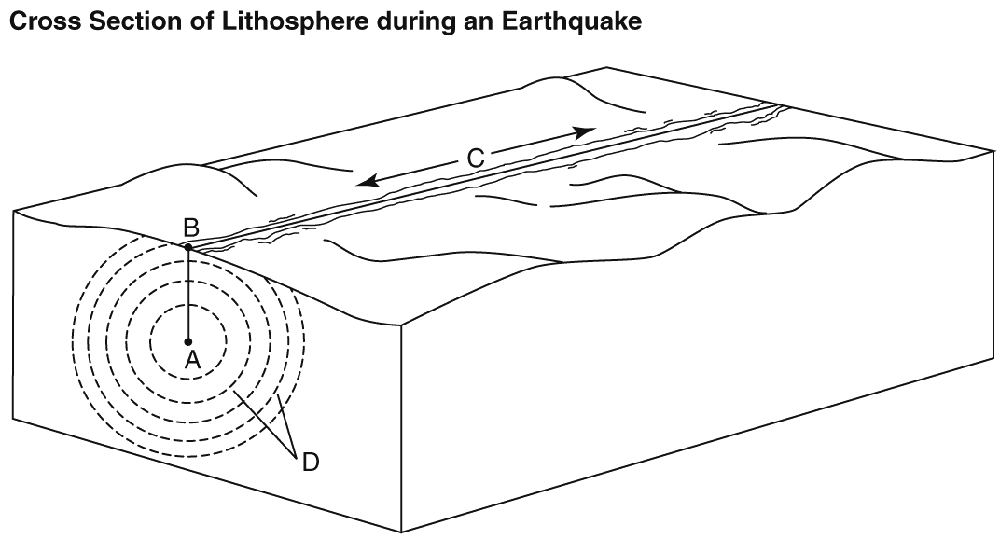

Earth’s history and Change over time
Amber | Frozen in ice | Petrified | Fossil | Evolution | Adaptation
Natural selection | Extinct | Variation | Index fossil | Relative | Absolute
Isotope | Half life | Carbon | Uranium | Trace | decay

- What do we call the preserved remains or traces of a dead organism _________________
- The process in which a species changes over time _________________
- Process by which individuals better suited to their environment survive and reproduce ______________
- A trait that improves chances of survival and reproduction for a group of individuals in a population____________
- What type of fossil preserves remains of an insect with little or no change ___________________
- A fossil formed when minerals replace all or part of an organism__________________
- A fossil that provides clues about activities of ancient organisms _________________
- Fossils that were widely distributed but only lived for a short period of time ___________________
- An organism that no longer exists on earth ____________________
- Radioactive dating enables geologists to determine __________________ age.
- A rocks age compared to the ages of other rocks ________________ age
- What do we call the time it takes for half of the radioactive atoms in a sample to decay __________________
- What is it called when an unstable isotope breaks down into a more stable isotope?____________________
- Which isotope would you use to find the absolute age of a once living specimen ___________________
- Which rock layers are older than layer 4. _________________
- Which rock layers are newer than layer 4 ___________________
- Which is older, the intrusion or layer 5 ___________________
- Which layer is more likely to contain fossils 4 or 5 – why?
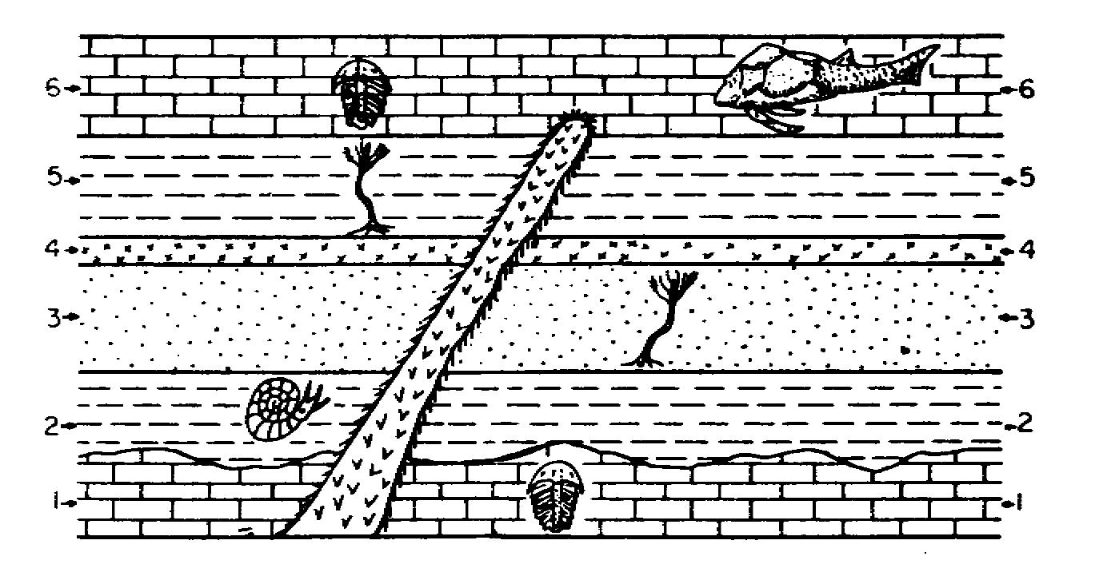

Name_____________________________________ Final Exam Review Sheet
Wave | Medium | Solid | Liquid | Gas
Mechanical | Electromagnetic | Visible light | Rainbow | Radio
Gamma | Xray | Microwave | Ultraviolet | Infrared
Crest | Trough | Wavelength | amplitude | Solid
Liquid | gas
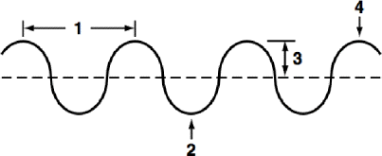
Waves
- What is a disturbance that transfers energy from place to place _________
- The material through which a wave travels __________________
- Which kind of material do mechanical waves travel through most quickly?___________________
- Label the parts of the wave
1_________ 2__________3____________4____________
- Which kind of wave does NOT need a medium? __________________
- Which EM waves have the highest frequency?________________
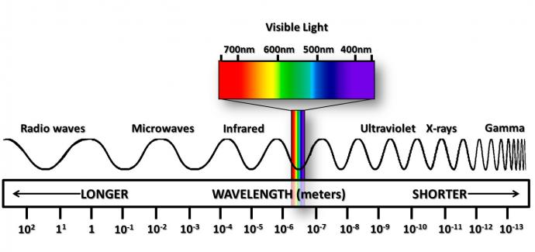
- What kind of wave does a police officer use for speed control ________________________
- What is visible light_______________
- What is the relationship between wavelength and frequency in e-m waves?______________________
- Label the example of reflection and refraction and and absorption, transmission Draw a beam scattering
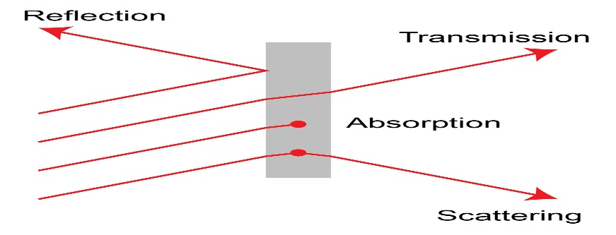

Energy Transfer and Heat
Heat | MRS CHEN forms of energy | Law of conservation of energy | Faster | Slower | Temperature
Convection | Conduction | Radiation | insulation
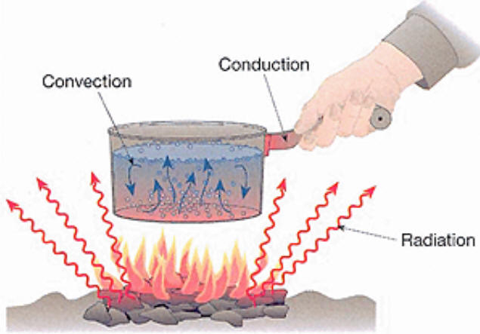
- You warm your hands by rubbing them together. The friction converts ___________ to __________ energy
- A flashlight is left on. The chemical energy has changed to __________ and _____________
- Energy cannot be crated or destroyed it just changes forms ____________________________
- object________________
- Which process should the person at right use to protect his hand_________
- Label the Heat transfer processes that are taking place in the following picture: convection/conduction/radiation

Land degradation | Air pollution | Water pollution | Point source | Non point source
Rural | Urban | Natural | Agriculture | recreation
Deforestation | Erosion | desertification
Human Impact
- An area with a large human population and higher levels of air pollution ____________
- Human activity that damages the land to the point it can no longer support an ecosystem______________
- Pollutants that enter a body of water at a specific identifiable location _________________________
- Vehicle emissions can lead to __________________
- Pollution that does not have a specific identifiable source ____________________
- Areas with a small human population and more open spaces __________________________

